**Project Design Phase-II**

**Technical Architecture**

|  |  |
| --- | --- |
| Date | 04 November 2023 |
| Team ID | NM2023TMID08774 |
| Project Name | Project - Digital Marketing |
| Maximum Marks | 4 Marks |

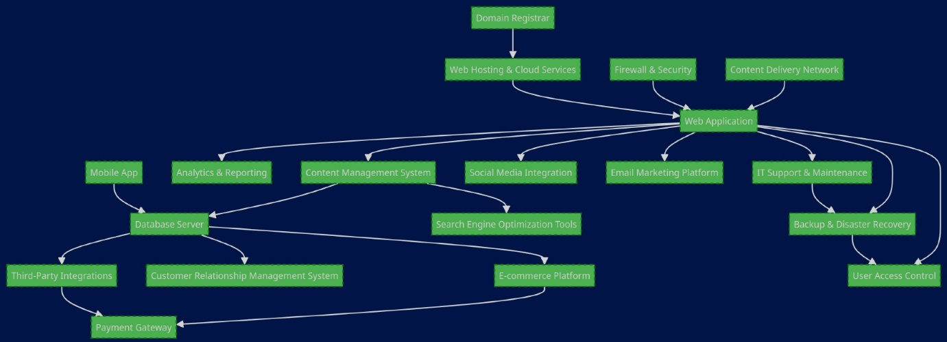

**Technical Architecture:**

The technical architecture of a modern restaurant would typically involve a combination of hardware, software, and networking components to support various aspects of the restaurant's operations. Here's an overview of the key elements of a restaurant's technical architecture:

1. Point-of-Sale (POS) System: The central component of the restaurant's technical infrastructure, the POS system manages order processing, payment transactions, and inventory control. It includes touchscreen terminals for taking orders, printing receipts, and managing customer bills.
2. Kitchen Display Systems (KDS): KDS screens or printers in the kitchen display orders to chefs, helping them prepare and prioritize dishes efficiently. The KDS is connected to the POS system, ensuring seamless order flow.
3. Reservation and Table Management Software: This software assists in managing reservations, table assignments, and waitlist tracking, optimizing the seating process for customers. It can also integrate with the POS system to streamline order placement.
4. Inventory Management System: Inventory software tracks stock levels, monitors ingredient usage, and generates alerts for restocking. It helps reduce food waste and ensures that necessary ingredients are always available.
5. Customer Relationship Management (CRM): CRM software stores customer data, tracks preferences, and facilitates loyalty programs, allowing the restaurant to provide personalized experiences and promotions.
6. Online Ordering and Delivery Platform: Restaurants may use a third-party or proprietary online ordering system for takeout and delivery orders, integrated with the POS system for order processing.
7. Payment Processing: Secure payment processing solutions are essential for handling credit card and digital payments. This involves payment gateways, encryption, and compliance with payment industry standards.
8. Wireless Network: A reliable and secure wireless network enables communication between devices such as POS terminals, tablets for order taking, and the kitchen display system. It also supports guest Wi-Fi access.
9. Data Storage and Backup: The restaurant's technical architecture includes data storage systems for transaction records, customer information, and operational data. Regular backups are essential for data recovery in case of system failures.
10. Security and Surveillance Systems: To ensure the safety of staff and guests, the restaurant may have security cameras and alarm systems, which can be integrated into the overall technical infrastructure.
11. Digital Signage: Digital menu boards and promotional displays can be part of the restaurant's architecture to showcase the menu, special offers, and branding.
12. Mobile Apps and Website: Many restaurants have mobile apps and websites to facilitate online reservations, menu browsing, and ordering. These digital platforms need hosting and a backend architecture.
13. Cloud Services: Cloud computing services may be used for data storage, scalability, and backup solutions, providing flexibility and cost-efficiency.
14. IT Support and Maintenance: A technical architecture necessitates IT support and maintenance for ongoing system updates, troubleshooting, and ensuring the reliability of the restaurant's technology.
15. Guest Feedback and Analytics Tools: These tools gather feedback from customers and provide analytics to help the restaurant improve its services.

**The technical architecture of a restaurant is designed to enhance efficiency, customer service, and overall management, creating a seamless dining experience for customers while supporting the restaurant's operational needs.**